- The intensity I, that is the power passing per unit area, of an electromagnetic wave in which the amplitude of the electric field strength is E_{o} is given by
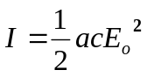
where a is a constant equal to 8.85 × 10⁻¹² C V⁻¹ m⁻¹ and c is the speed of light.

- (i) State the S.I. units for intensity I .
I =………..…………..[1]
(ii) State the S.I. units for electric field strength E_{o}.
E_{o} =……….…………..[1]
(iii) Hence, check if the above equation is homogeneous with respect to units.

[2]

- Calculate a value for E_{o} in a wave of intensity 1.40 × 10³ W m⁻², the Sun’s intensity at Earth.

E_{o} =………………..[1]

- Given that intensity is inversely proportional to the square of distance, determine the value of the intensity of the Sun’s radiation at a distance from the Sun equals to 20 times the Sun-Earth distance.

I =………………..[2]
- A car is travelling along a straight road at speed v. A hazard suddenly appears in front of the car. In the time interval between the hazard appearing and the brakes on the car coming into operation, the car moves forward a distance of 32.5 m. With the brakes applied, the front wheels of the car leave skid marks on the road that are 15.4 m long, as illustrated in Fig. 2.1.

Position of car when hazard appears
Skid mark
32.5 m
15.4 m
v

Fig. 2.1.

It is estimated that, during the skid, the magnitude of the deceleration of the car is 0.85 g, where g is the acceleration of free fall.

- Determine
(i) the speed v of the car before the brakes are applied,

v = …………………… m s^{–1} [2]

(ii) the time interval between the hazard appearing and the brakes being applied.

time = ……………..…………. s [2]

- The legal speed limit on the road is 60 km per hour.
Use both of your answers in (a) to comment on the standard of the driving of the car.
………………………………………………………………………….…………
………………………………………………………………………….…………
………………………………………………………………………….…………
………………………………………………………………………….…………
……………………………………………………………………….…………[3]

- A free-body force diagram for a travel case of total mass 5.5 kg is shown in Fig. 3.1. The case is being held at rest by a hand at H, and its centre of gravity is at G. The diagram is drawn to scale at one fifteenth real size.
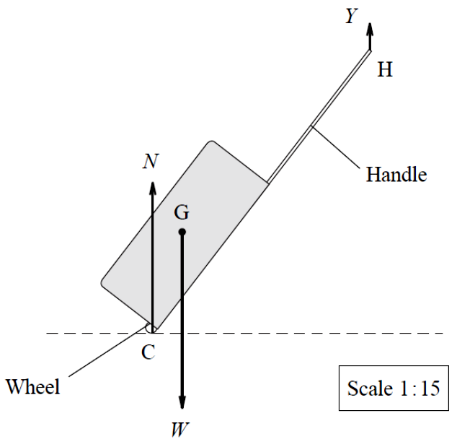

Fig. 3.1
- Use the principle of moments to calculate the magnitude of the force Y, the upward pull of the hand on the case.

Y = ………………. N [3]
- State and explain two ways in which the force Y could be reduced without altering the total mass of the case or further extending the handle.
………………………………………………………………………….…………
………………………………………………………………………….…………
………………………………………………………………………….…………
………………………………………………………………………….…………
……………………………………………………………………….…………[4]

- A lift is designed to hold a maximum of 15 persons. The lift cage has a mass of 600 kg and the distance from the top floor of the building to the ground is 62 m. The ultimate tensile stress and the Young modulus of the cable are 4 x 10⁸ Pa and 210 GPa respectively.

  - Comment qualitatively on the mechanical properties of the cable which is described above.
………………………………………………………………………….…………
………………………………………………………………………….…………
………………………………………………………………………….…………
……………………………………………………………………….…………[2]

  - Make a reasonable estimate for the total weight of 15 persons and hence estimate the minimum area of the cable to support the lift and the persons in it.

area = ………………………… m² [3]

  - State two reasons why in practice the cable would have to be thicker than that in the calculated value.
………………………………………………………………………….…………
………………………………………………………………………….…………
……………………………………………………………………….…………[2]

- (a) Sound is said to be a longitudinal wave. What is meant by “longitudinal”?
………………………………………………………………………….…………
……………………………………………………………………….…………[2]

(b) L₁ and L₂ are two loudspeakers emitting sound waves of same frequency. A microphone M is moved gradually from X to Y.

microphone
L₁
L₂
Signal generator
M
X
Y
O
C.R.O.

- Describe the sound intensity detected at point O. Explain your answer.
……...……………………………………………………………….………..
……...……………………………………………………………….………..
…...……………………………………………………………….………..[2]

- State and explain any change in the sound pattern along XY when

- the frequency of the sound is doubled.
……...……………………………………………………………….………..
……...……………………………………………………………….………..
…...……………………………………………………………….………..[2]

- L₁ is out of phase with L₂ by 180⁰.
……...……………………………………………………………….………..
……...……………………………………………………………….………..
…...……………………………………………………………….………..[2]

- (a) Two pairs of parallel deflection plates, plates X and plates Y, are arranged vertically as shown in Fig. 6.1. A potential difference of 100 V is applied between the plates. An electron enters at a certain velocity and passes through the region between the deflection plates. The effect of gravity is neglected.

- Define electric field strength.
……...……………………………………………………………….………..
…...……………………………………………………………….………..[1]

- On Fig. 6.1, sketch a possible path of the electron in the fields. [2]

+100V
0V
Plates X
+100V
0V
Plates Y
electron

Fig. 6.1

(b) A proton is accelerated from rest through a potential difference of 100 V.

Calculate the speed attained by the proton.

speed = ………………….. ms⁻¹ [3]

- An electrical heating element is to be designed so that the power dissipated will be 750 W when connected to a 120 V supply of negligible internal resistance.

  - Calculate the resistance of the heating element needed.

resistance = ………………. Ω [2]

  - The element is to be made from nichrome ribbon 1.0 mm wide and 0.05 mm thick. The resistivity of nichrome = 1.1 × 10⁻⁶ Ω m.
Calculate the length of the ribbon required.

length = ……………….. m [2]

  - Draw a complete circuit diagram to show how a second identical element would be connected to increase the power dissipated to 1.5 kW.

[1]
- (a) State Kirchhoff’s laws for electrical circuits.
1. ……………………………………………………………………….…………
………………………………………………………………………….…………
………………………………………………………………………….…………
2. ……………………………………………………………………….…………
…………….……………………………….…………………………….……….
…………………………………………………………………………….……[2]

(b) A charger of e.m.f. 15 V and internal resistance 0.50 Ω is used to charge a battery of e.m.f. 9 V and internal resistance 0.10 Ω. They are connected in series together with resistance R which value is adjusted to give a charging current of 3.2 A.
R
3.2 A
E₂ = 9 V
r₂ = 0.10 Ω
E₁ = 15 V
+ −
r₁ = 0.50 Ω
Calculate:
- the value of R.

R = ………………. Ω [2]

- the power supplied by the charger.

power = ……………….. W [1]
- the total rate of dissipation of electrical energy due to resistance.

power = ……………….. W [2]

- Comment on the difference between your answers to (ii) and (iii).
…………………………………………………………………….…………..
..………………………………………………………………….…………[1]

- (a) Distinguish between α-particles and β-particles in terms of charge, mass and penetration.
………………………………………………………………………….…………
………………………………………………………………………….…………
………………………………………………………………………….…………
………………………………………………………………………….…………
………………………………………………………………………….…………
………………………………………………………………………….…………
……………………………………………………………………….…………[3]

(b) A radioactive isotope of Thallium, 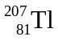 is known to decay to nuclide Pb by emitting a β-particle.
Write an equation for this decay.

………………………………………………………………………….……….[2]

